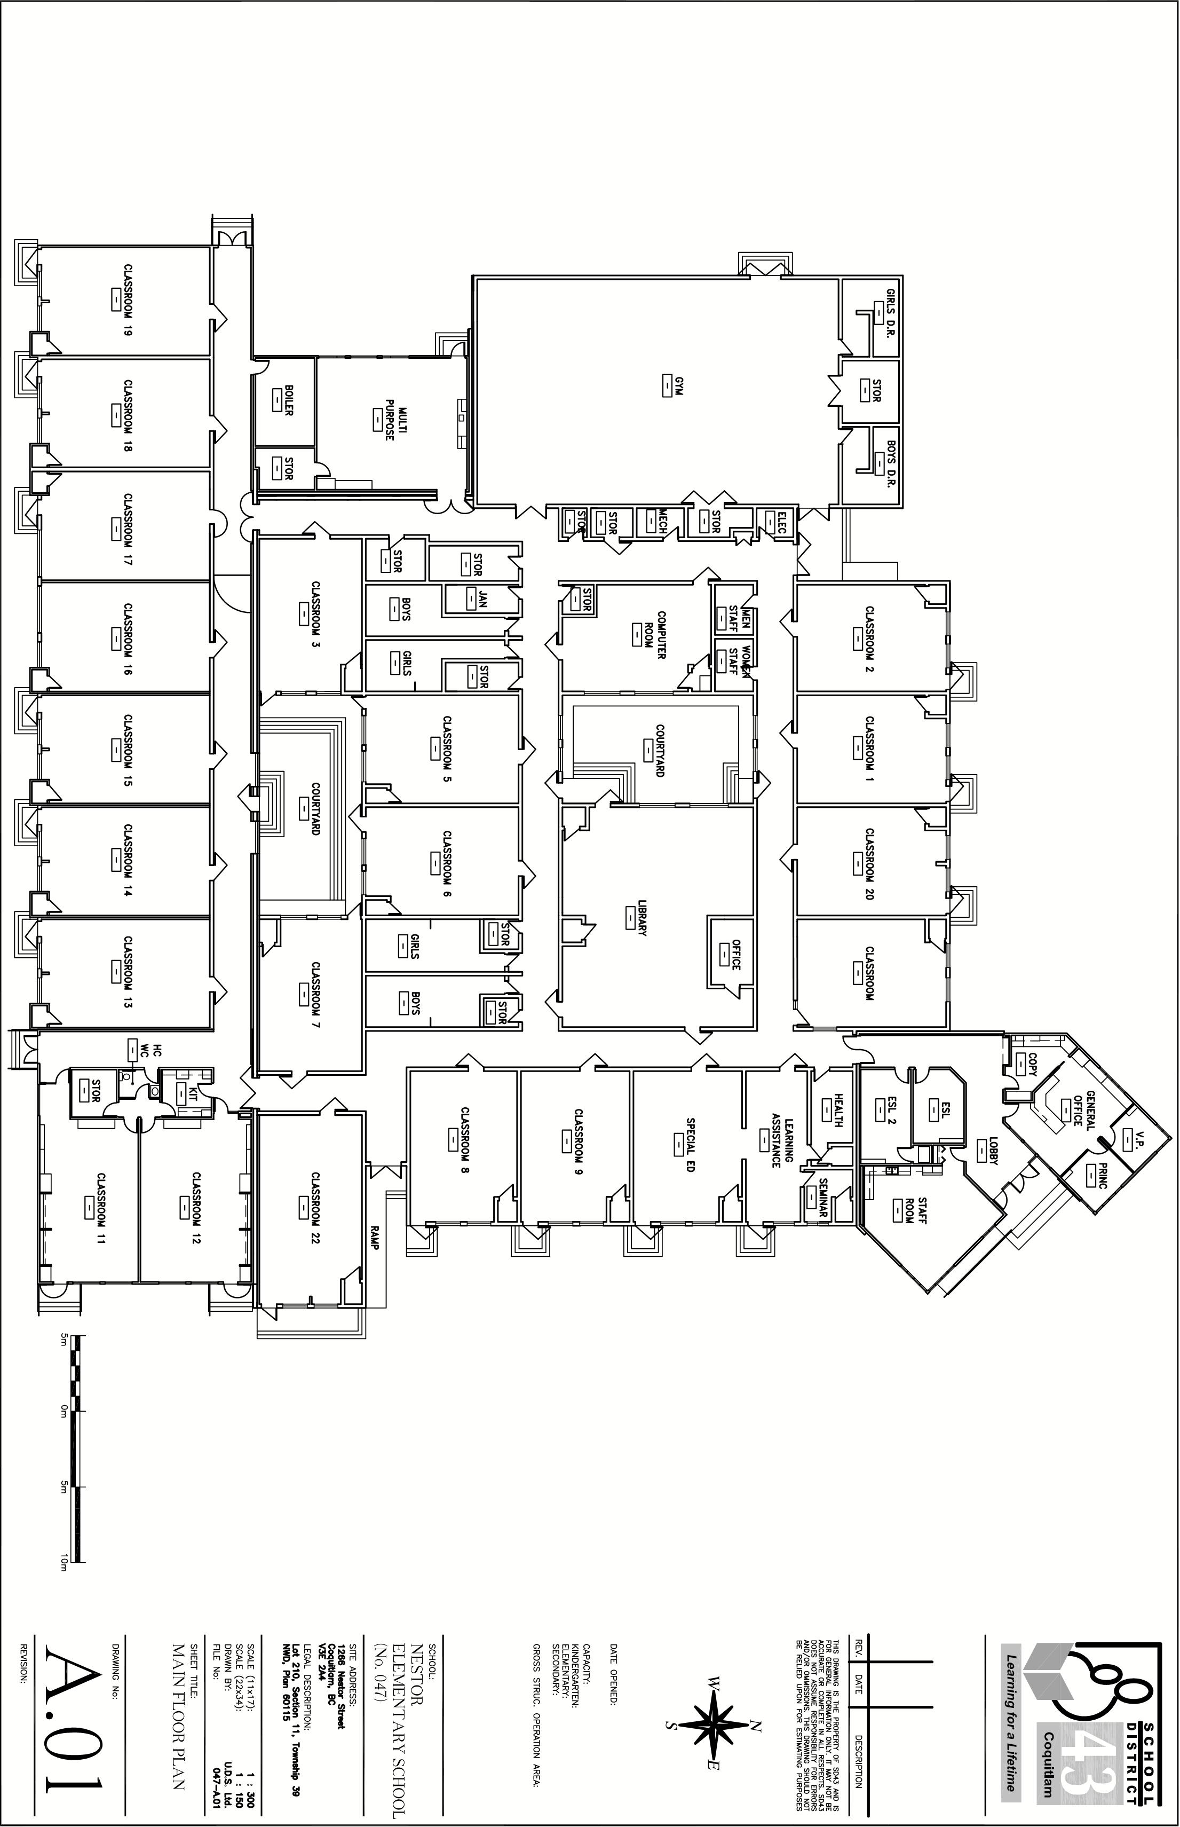

**FRENCH**

**GRADE**

**4/5**

**ENGLISH**

**GRADE**

**1**

**ENGLISH**

**GRADE**

**5**

**ENGLISH**

**GRADE**

**4**

**ENGLISH**

**GRADE**

**2**

**FRENCH**

**GRADE**

**3**

**FRENCH**

**GRADE**

**1**

**FRENCH**

**GRADE**

**2**

**ENGLISH**

**GRADE**

**3**

Ecole Nestor Elementary

**DISMISSAL AREAS for Monday, September 9, 2024**

1266 Nestor Street, Coquitlam BC V3E 2A4

**Pearce**

Rm. 18

**McDonald**

**025**

[Grab your reader’s attention with a great quote from the document or use this space to emphasize a key point. To place this text box anywhere on the page, just drag it.]

[Sidebars are great for calling out important points from your text or adding additional info for quick reference, such as a schedule.

They are typically placed on the left, right, top or bottom of the page. But you can easily drag them to any position you prefer.

When you’re ready to add your content, just click here and start typing.]

[Sidebar Title]

**Djekanovic**

Rm. 15

**Keeler**

Rm. 16

**Sibley**

Rm. 17

**Zaleski**

Rm. 19

**Primavera**

Rm. 20

**EAL**

**Murray**

Rm. 9

**Pandolfo**

Rm. 5

**Strain**

Rm. 13

**Baldwin**

Rm. 7

**Coghill**

Rm. 21

**Dorcas**

Rm. 8

**Didovic**

Rm. 14

**Torres**

Rm. 12

**Office**

**Watson**

Rm. 10

**Renning**

Rm. 11

**Library**

**Skill Room**

Rm. 1

**Bower**

Rm. 2

**Kokkas**

Rm. 3

**Peressin**

Rm. 4

**Learning**

**Assistance**

Rm 22

**Loss**

Rm. 6

**Music**

**Kiddie**

**Gym**